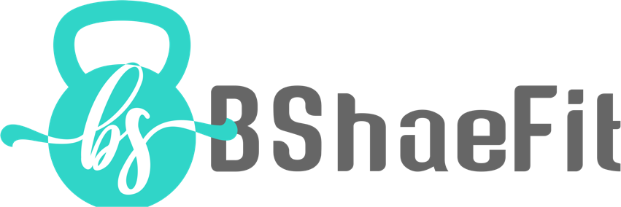n In

Thank you SO MUCH for the interest in joining Team BShaeFit!

Please, provide the following information prior to purchasing a program to ensure we are a good fit and/or that I can provide you the service that you are looking for! Once completed e-mail it to: BShaeFit@gmail.com

Your Name:
Your E-mail Address:

Have you worked with me before?

If you are a prior/current client –
How long have you been working with me?

What plans/programs have you ordered in the past?

If you have not worked with me before-

How did you hear about my coaching- please choose all that apply:

__ Friend/family member

__ Website

__ Instagram
__ Pinterest

__ Facebook

_______ Other (please list)

Personal information:
Your Age:
Your Height (feet and inches):
Your Weight (pounds):

Do you have any significant medical history and/or injuries?

Are you pregnant and/or breastfeeding?

Please attach photos- front, back, and side

Exercise questions -

Any limitations exercise or any prior issues you may be concerned of?

How many days per week do you exercise?

Where do you exercise mostly?

Do you plan on exercising at home or the gym?
If home, do you have any home equipment or are you ok with purchasing a few simple items?

Do you do any resistance exercise/weight lifting?

How much cardio (minutes/days) are you currently doing per week? What types?

How many days per week would you be able to exercise? How many days do you prefer?

Nutrition questions –

What does a typical day of eating look like for you?

Do you currently weigh and/or measure your food?

Do you track macronutrients using a food log app?
if so, what are your current fat, carbohydrate, and protein levels?

If you haven’t tracked calories/macronutrients, are you against doing so?

Would you prefer a less strict approach with nutrition or are you more interested in precision?

Do you have any history of disordered eating habits?

What are you looking for in regards to changing your nutritional habits?

General questions -

What have been your biggest barriers in your current health and wellness journey?

What do you NEED THE MOST from a coach?

What do you look for in a coach?

What have you done in the past that HAS NOT worked for you?

Do you prefer a strict approach or more balance?

What are your goals, short term?
What about long term?

1:1 coaching plans offered that require this screening form (each includes check-ins)

- Definition of “Check-ins”: Each client is responsible to fill in a questionnaire I provide on the plan that is to be e-mailed to me on a designated check-in day. It is a core principle of a behavior change (evaluating weekly progress) and vital for accountability. Feedback will be provided each week on your plan. This is to ensure proper carryover of the plan as well as continued education, instilling habits, and improving areas that you are having difficulty with.

Options offered:
- B Well plans (workouts plus nutrition)
- B Nutritious plans (nutrition only)

If you prefer plans without the check-ins, I do have the monthly workout options (custom & non-custom) as well as one time macronutrient calculations!

Please list the plan option that you are interested in _________
Or, Would you like my suggestion on choosing a plan that is best for you?

How motivated are you, on a scale from 1-10, 10 being VERY motivated
_____

I look forward to hearing from you, Thank you!

