 | Radiokop Residents Association News Letter |  | December 2019
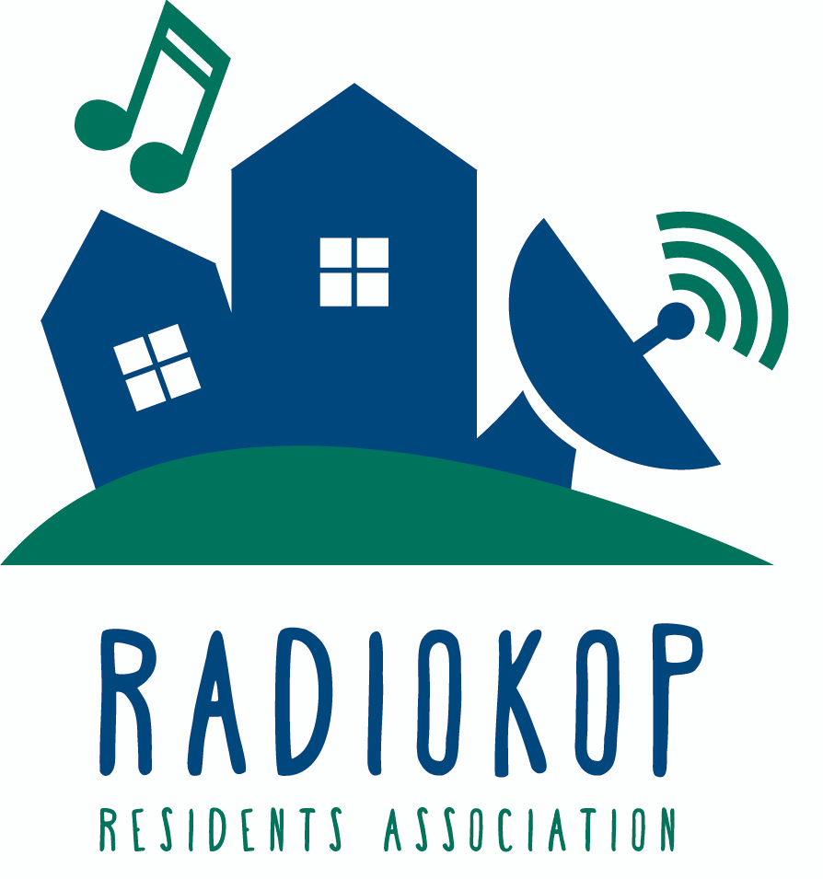

Chairperson’s report
Hi everyone,  Welcome to our latest newsletter where we will give you an overview of what the RRA has been up to over the last couple of months.  - Concrete balls repaired and replaced on the corner of John Vorster and Opera roads  - Camera replacements around the neighbourhood.  - Clean ups: The RRA has retained the services of Joe to help remove illegal advertising, pick up litter and generally keep our neighbourhood tidy. If you see him hard at work, give him a friendly wave as it’s thanks to his hard work that our area is looking spick and span. We hope to have clean ups on a monthly basis.  - Normal service delivery follow-ups e.g. Cutting back trees around Melody, JRS barrier on Opera road outside the Irish Rock pub and other roads in our area has been followed up on.  - Regular newsletter creation and template. We hope to publish these quarterly. |  | Still in progress or still to do:  - Quotes for blackboards under every RRA sign.  - Tree/bush cutting back quote organising along Christiaan de Wet, John Vorster and along the Sentech road, to deter criminals from hiding there.  - Extending the concrete balls along the corner of John Vorster and Opera Road  RRA Committee changes  We have found a replacement secretary for Bev Butcher who left our area a while ago. A big to Bev, we will really miss you.  Welcome to Lisa-Marie Henning who will be assisting us from a secretary point of view to assist with meeting minutes, our residents’ lists and other items to support the RRA team. You will see her overview later on in the newsletter.  We are in need of a treasurer as our current treasurer, Vanessa Boshoff, is stepping down. This is a voluntary position. Interested applicants please email Carolyn on carolynlanz@gmail.com or rracommittee@gmail.com. | Security Tip of the month  Looking out for you:  Domestic workers are being targeted very regularly these days by people pretending to be couriers or governmental employees or other types of workers.  Please ensure your domestic workers are aware to not let any unknown people into your property and if they feel threatened to lock themselves inside if someone unknown asks to be let in.
ADDITIONAL 2019 FOCUS AREAS

Security: The cameras that are positioned around our area are not always unmonitored, however we are in the process of investigating the cost of full time monitoring with our local security companies EC Security and GP Tactical.
Website Development:
The RRA is looking for a designer to update the association’s website, interested parties can contact rracommittee@gmail.com.

The RRA team

- Carolyn Lanzillotti
Chairperson
Ward 97 Councillors, JHB Water, PIKITUP, Cement Dustbins, Sentech and GED land.
- Andrew Miller
Deputy Chairperson
Responsible for liaising with City Parks, Provincial Roads, City Power, Incident/Emergency management planning.
- Vanessa Boshoff
Treasurer
Financials
- Luis Almeida
Security & PI Chairperson
Responsible for liaising with SAPS, JRA, JMPD, Security companies.
- Lisa-Marie Henning
Secretary
Committee meeting minute taking and membership lists
- Adele von Berg
Radiokop business listing and RA, Linkages to Animal Welfare and NPOs.
- Alison Job
Newsletters, Social media including Facebook and Whatsapp.
Security

Business listings in the area
Please contact rracommittee@gmail.com to add your business to our listing or advertise in our newsletter.
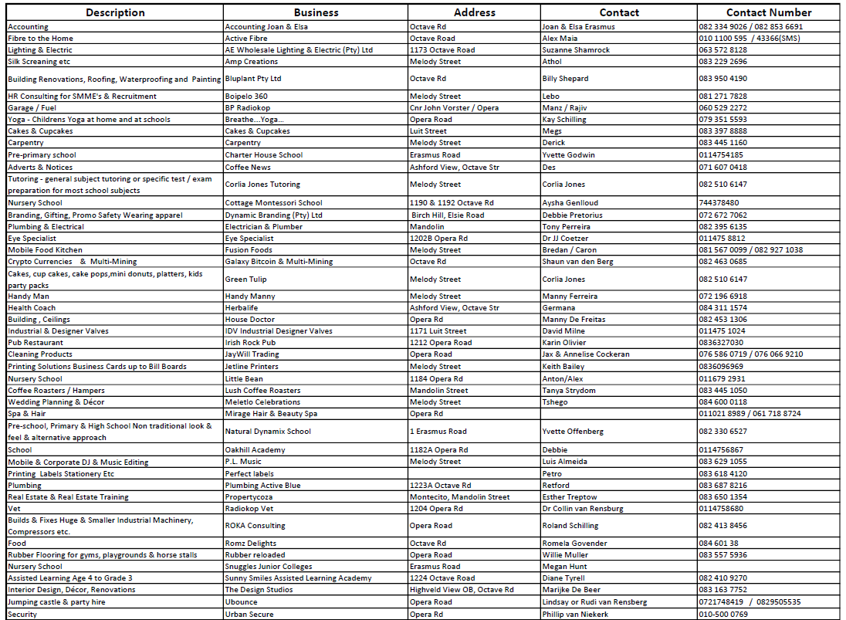
Recommended service to make use of to keep you and your company safe
BACKGROUND CHECKS - Contact Lebo Moloabi on 0812717828 for more information or advice on how to go about requesting a background check.
Even though hiring can be a long, drawn-out and even tedious task, it is always worth the extra effort to run a background check on your potential hires whether corporate or domestic workers. Here is a list of reasons why it is important to not only you, but your company and clients.
1. Criminal Convictions 2. Reduce Your Liability Risk 3. Know Your Hire
4. Protect Your Employees, Company and Clients 5. Verify Education and Certifications 6. Peace of Mind

